**CS673 Software Engineering** 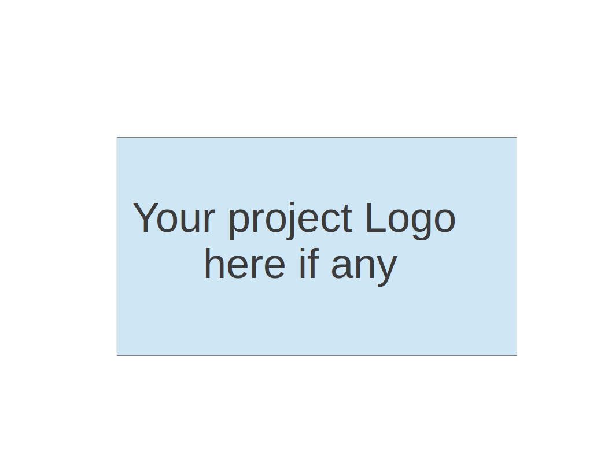

**Team 4 - ResumAI**

**Software Test Document**

| Team Member | Role(s) | Signature | Date |
| --- | --- | --- | --- |
| Hemant Krishnakumar | Team Lead |  | 11-07-2024 |
| Faizan Ahmad | Design and Implementation Lead |  | 11-07-2024 |
| Tushar | Requirement Lead |  | 11-07-2024 |
| Shubh Gupta | Q/A Lead |  | 11-07-2024 |
| Amruth Reddy | Security Lead |  | 11-07-2024 |
| Jaindra Parvathaneni | Configuration Lead |  | 11-07-2024 |
|  |  |  |  |
|  |  |  |  |

**Revision history**

| **Version** | **Author** | **Date** | **Change** |
| --- | --- | --- | --- |
| **1** | **Shubh Gupta** | **11-07-2024** | **New** |
| **2** | **Shubh Gupta** | **12-08-2024** | **Node Tap Setup**  **Framework for mocking db calls and keycloak**  **Test Cases for API Routes** |

Testing Summary

Manuel Tests Reports

Automated Testing Reports

Testing Metrics

References

Glossary

# Testing Summary

* **Tested Components**: Key frontend and backend units like login, registration, and recruiter shortlist.
* **Involved**: Development team, with QA input on test cases.
* **Timing**: Unit tests during development; automated tests on every commit via Husky.
* **Techniques**: Unit testing with Jest, Husky pre-commit hooks, mocking, and snapshot testing.
* **Results**: All unit tests passed; minor issues fixed; Husky successfully blocks commits with errors.

# Manual Testing Report

**Test Case 1: Login Page**

* **New or Old**: New
* **Test Items**: Verifying login functionality with correct and incorrect credentials
* **Test Priority**: High
* **Dependencies**: Registration Page
* **Preconditions**: User must be registered in the system
* **Input Data**: Valid and invalid email/password combinations
* **Test Steps**:
  1. Navigate to the login page.
  2. Enter valid credentials and submit.
  3. Enter invalid credentials and submit.
* **Postconditions**: User is redirected to the homepage on successful login, receives an error on failure.
* **Expected Output**: Successful login redirects to the homepage; unsuccessful login displays an error message.
* **Actual Output**: Redirects to the homepage on success; error message on failure.
* **Pass or Fail**: Pass
* **Bug ID/Link**: N/A
* **Additional Notes**: N/A

### **Test Case 2: Registration Page**

* **New or Old**: Old
* **Test Items**: Verifying registration with valid and invalid data
* **Test Priority**: High
* **Dependencies**: Login Page
* **Preconditions**: None
* **Input Data**: Various email/password combinations, including valid, invalid, and duplicate data
* **Test Steps**:
  1. Navigate to the registration page.
  2. Enter valid user details and submit.
  3. Attempt registration with duplicate email and invalid data.
* **Postconditions**: Registration completes successfully, or the user is informed of errors.
* **Expected Output**: Successful registration redirects to the login page; errors are shown for invalid data.
* **Actual Output**: Works as expected.
* **Pass or Fail**: Pass
* **Bug ID/Link**: N/A
* **Additional Notes**: Check for edge cases with duplicate registrations.

### **Test Case 3: Analytics Page**

* **New or Old**: New
* **Test Items**: Verify analytics page data loads and displays correctly
* **Test Priority**: Medium
* **Dependencies**: None
* **Preconditions**: User must be logged in
* **Input Data**: N/A
* **Test Steps**:
  1. Log in and navigate to the analytics page.
  2. Verify that data loads correctly for each category.
* **Postconditions**: Data appears as expected.
* **Expected Output**: All graphs and data should load and be interactive.
* **Actual Output**: Data loads with slight delays in some sections.
* **Pass or Fail**: Pass
* **Bug ID/Link**: N/A
* **Additional Notes**: Consider optimizing load times.

### **Test Case 4: Shortlist Page**

* **New or Old**: New
* **Test Items**: Verify adding and removing candidates from the shortlist
* **Test Priority**: Medium
* **Dependencies**: Job listing page
* **Preconditions**: User must have viewed job listings
* **Input Data**: Candidate profiles
* **Test Steps**:
  1. Navigate to the shortlist page.
  2. Attempt to add candidates to the shortlist.
  3. Remove candidates from the shortlist.
* **Postconditions**: Candidate is added or removed from the shortlist.
* **Expected Output**: Candidates appear in the shortlist; removal works as expected.
* **Actual Output**: Works as expected.
* **Pass or Fail**: Pass
* **Bug ID/Link**: N/A
* **Additional Notes**: Ensure shortlist updates in real time.

### **Test Case 5: Job Listing Page**

* **New or Old**: Old
* **Test Items**: Verify job listings load and filters function correctly
* **Test Priority**: High
* **Dependencies**: Login Page
* **Preconditions**: User must be logged in
* **Input Data**: Job titles, company names, and filters
* **Test Steps**:
  1. Navigate to the job listing page.
  2. Apply various filters and sort options.
  3. Open specific job listings.
* **Postconditions**: Filtered jobs load and details display correctly.
* **Expected Output**: Job listings display as per applied filters.
* **Actual Output**: Works as expected.
* **Pass or Fail**: Pass
* **Bug ID/Link**: N/A

### **Test Case 6: Landing Page**

* **New or Old**: Old
* **Test Items**: Verify landing page content and responsiveness
* **Test Priority**: Low
* **Dependencies**: None
* **Preconditions**: None
* **Input Data**: N/A
* **Test Steps**:
  1. Navigate to the landing page.
  2. Check content and responsiveness across devices.
* **Postconditions**: Page should load quickly and be responsive.
* **Expected Output**: Content displays correctly on all screen sizes.
* **Actual Output**: Works as expected.
* **Pass or Fail**: Pass
* **Bug ID/Link**: N/A
* **Additional Notes**: Test on different browsers and devices.

# Automated Testing Report

### **Husky in Automated Testing**

* **Purpose**: Husky is used to enforce pre-commit hooks, automatically running tests and checks to ensure code quality before each commit.
* **Pre-commit Hooks**: When a developer commits code, Husky triggers:
* **Jest Tests**: Runs unit tests to verify core functionality and catch issues in new changes.
* **Nodetap Tests**: Executes server-side tests, particularly for Node.js components, ensuring backend stability.
* **Linting**: ESLint checks for code style and formatting errors.
* **Commit Blocking**: If any test fails, Husky blocks the commit, ensuring issues are fixed before pushing code.
* **Configuration**: Configured in the .husky directory at the project root, specifying commands for linting, Jest, and Nodetap tests in the pre-commit hook.

Husky’s integration ensures consistent code quality by catching potential issues early in the development workflow.

# Node Tap Setup

* **Node Tap Setup for Backend**:  
  Set up the Node Tap testing framework to enable efficient and scalable testing for the backend services. Node Tap provides a simple syntax for writing tests, running them, and generating detailed reports. The setup ensures a clean testing environment with isolated test cases, promoting modularity and maintainability of the backend codebase.
* **Framework for Mocking DB Calls and Keycloak**:  
  Developed a robust framework to mock database calls and Keycloak authentication, enabling effective testing of APIs without relying on live databases or external authentication services. This framework mimics the responses from the database and Keycloak, facilitating consistent and predictable test outcomes while significantly reducing test execution time.
* **Test Cases for API Routes (40% Completed)**:  
  Created test cases covering 40% of the backend API routes to ensure they handle various request and response scenarios effectively. These test cases validate the functionality, edge cases, and error handling of the routes, contributing to a more stable and reliable application. The remaining test coverage is in progress, aiming for complete API route validation.

# References

1. Jest Documentation - <https://jestjs.io/docs/getting-started>
2. Husky Documentation - <https://typicode.github.io/husky/#/>
3. Nodetap Testing Framework - <https://www.npmjs.com/package/tap>
4. ESLint Documentation - <https://eslint.org/docs/user-guide/getting-started>

# 